2024 NED MOCK
BIOLOGY PAPER II (PRACTICAL) MARKING KEY
Question 1
- Take the boiled and cooled water in a test tube
- Add some sugar to it and stir to make sugar solution
- Add some yeast to it and stir then add a layer of oil
- Put limewater in a conical flask
- Connect the conical flask to the test tube using a tube
- Support the tube in a conical flask using a cork
- Leave the set up for about one hour and observe the results
- Limewater in the conical flask turns milky
- Carbon dioxide reacts with limewater and cause it to become cloudy/milky
- The experiment shows that carbon dioxide is produced during fermentation of yeast
10 marks
Question 2
Take/pluck /collect a fresh plant leaf ¹from the dry¹ ecosystem.
Hold the leaf by the petiole and dip¹ it in warm/hot water¹.
Observe¹ the presence of bubbles from both sides of the leaf.
Compare the number / concentration of air bubbles on both sides of the leaf ¹ and record ¹the results.
Repeat ¹the steps above using another leaf.
It is observed that the lower sides of the leaves contains high concentration (Number)¹ of bubbles of air, while lower sides contains few number of bubbles of air. The number of bubbles indicate the number of stomates
Therefore the lower surface of the leaf contains more stomates than the upper surface¹. 10 marks
OR
Take /pluck four leaves of the same type and relatively same surface area from one plant from dry¹ ecosystem.
Treat the leaves as follows,
Smear Vaseline on the upper and lower surface of the leaf and label it A¹.
Smear Vaseline on another leaf on the lower surface only and label it B¹
Smear Vaseline on another leaf on the upper surface only and label it C¹
Leave one leaf without smearing Vaseline and label it D¹.
Hung /Tie¹ the four leaves to a string or line to expose them to the sunlight.
Leave them for at least one hour
Observe¹ the dryness of the four leaves and record¹ the results in terms of order of dryness.
The order dryness for the leaves would as follows, leaf D will dry fast, then leaf C, the Leaf B, lastly leaf A¹
This indicate that the lower surface of the leaf contains more stomates than the lower surfaces¹. 10

Section B (20 marks)
3.
a. (i) Specimen X 1 mark
(ii) It is a Monocotyledonous seed 1marks
B i
Description | specimen | Observation
Size of flame | X | Burn with less flame.
 | Y | Burn with large flame
Substances produced | X | More Soot / a lot of smoke is produced
 | Y | Oil oozes / less soot
(4marks)
.C. (i) Hypertension / high blood pressure (1mark)
( ii) Kidney stones / Gout (1mark)
d. Aldosterone hormone. (1mark)
e. provide energy for respiration / excess is converted to starch and stored/ converted to
lipids. Any one (1mark)

4. a. (i) 1 mark for correct drawing (1mark)
2 marks for correct labelling any two parts (2 marks)
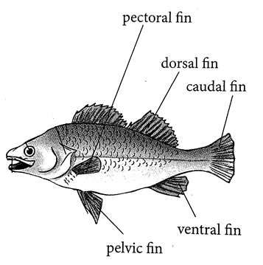
$ii.Magnification=\frac{length of drawing}{length of specimen}$
- 1 mark for Correct formula
- 1 mark for correct substitution
- 1mark for correct answer
(b) (i) streamlined shape (1 mark)
(ii) The shape prevents fish from experiencing drag/ reduces drag (1 mark)
(c) – protein
- calcium (2 marks)
THE END OF THE PAPER

_

3 marks

  - Colour, and Size 1 marks

d. Improvement in shelf life
High yielding
Pest resistant
- marks
e.
Crush the specimen in mortar and pestle.to obtain liquid extract.
Add DCIP reagent to the liquid extract and observe the colour.
Disappearing of the colour indicate that the specimen contains Vitamin C

3marks

END OF QUESTION PAPER

